**Wiring**

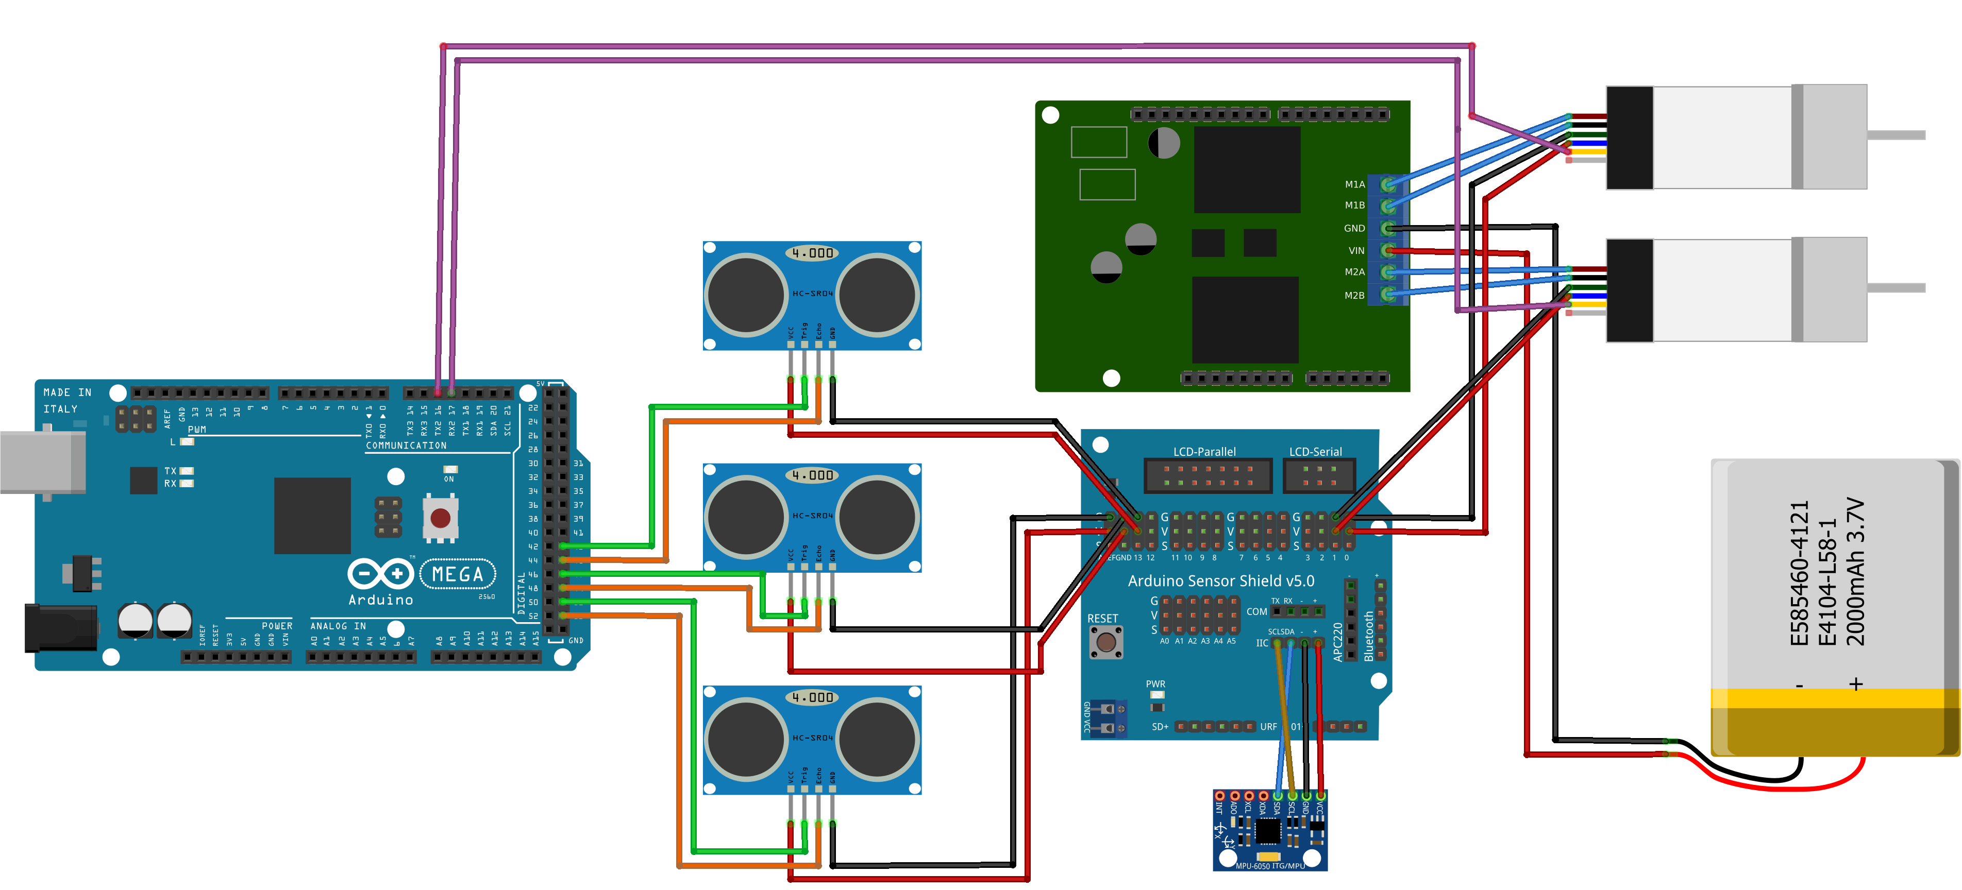Use the diagram and table below to wire Arduino components of the 'Jet' robot.

|  |  |  |  |
| --- | --- | --- | --- |
| **From** |  | **To** |  |
| **Component** | **pin** | **Component** | **pin** |
| Left Motor | red | Motor Shield | MIA |
| Left Motor | black | Motor Shield | M1B |
| Left Motor | green | Sensor Shield | 0G |
| Left Motor | blue | Sensor Shield | 0V |
| Left Motor | yellow | Arduino | TX2 16 |
| Right Motor | red | Motor Shield | M2A |
| Right Motor | black | Motor Shield | M2B |
| Right Motor | green | Sensor Shield | 1G |
| Right Motor | blue | Sensor Shield | 1V |
| Right Motor | yellow | Arduino | TX2 17 |
| Left Sonar Sensor | VCC | Sensor Shield | 13V |
| Left Sonar Sensor | Trig | Arduino | 43 |
| Left Sonar Sensor | Echo | Arduino | 45 |
| Left Sonar Sensor | GND | Sensor Shield | 13G |
| Center Sonar Sensor | VCC | Sensor Shield | GND-V |
| Center Sonar Sensor | Trig | Arduino | 47 |
| Center Sonar Sensor | Echo | Arduino | 49 |
| Center Sonar Sensor | GND | Sensor Shield | GND-G |
| Right Sonar Sensor | VCC | Sensor Shield | AREF-V |
| Right Sonar Sensor | Trig | Arduino | 51 |
| Right Sonar Sensor | Echo | Arduino | 53 |
| Right Sonar Sensor | GND | Sensor Shield | AREF-G |
| Battery | + | Motor Shield | VIN |
| Battery | - | Motor Shield | GND |
| MPU | VCC | Sensor Shield | IIC + |
| MPU | GND | Sensor Shield | IIC- |
| MPU | SCL | Sensor Shield | IIC-SCL |
| MPU | SDA | Sensor Shield | IIC-SDA |